Introduction to Deep Learning
Tutorial 1
Deep learning, which is based on conventional artificial neural networks, is often regarded as a subset of machine learning.
A connection in an artificial neural network is referred to as an artificial neuron. Similar to the biological brain network of the human body, artificial neural networks have a layered architecture and each network node (connection point) is capable of processing input and transmitting output to other nodes in the network.
Input layer — initial data for the neural network.
Hidden layers — intermediate layer between input and output layer and place where all the computation is done.
Output layer — produce the result for given inputs.
Input, output, and hidden layers are commonly present in conventional artificial neural networks. They only have one hidden layer because as the complexity and number of hidden layers rise, calculations become unstable and unfeasible.
Input, output, and several hidden layers are all included in deep learning neural networks.
Deep learning neural networks can have more than one hidden layer due to improved algorithms and higher computing power.
Deep learning neural networks can be generally divided into two types:
- Convolutional Neural Networks
- Recurrent Neural Networks
Convolutional Neural Networks are mainly for images, while Recurrent Neural Networks are mainly for sequence data, such as text and time series.
Deep learning can be dated back to 1989, when Yann LeCun and his colleagues proposed a structure for a convolutional neural network, called LeNet. LeNet was successfully used in handwritten digit recognition.
In 2010, Professor Feifei Li of Stanford University created the ImageNet, the largest image database that contains more than 14 million images of daily objects, divided into more than 20,000 categories, such as cats, dogs, cars, tables, chairs, and so on. ImageNet then launched an annual challenge on image classification, called ImageNet Large Scale Visual Recognition Challenge (ILSVRC). The ImageNet challenges only use 1,000 categories. The competitions ran from 2010 to 2017, and moved to Kaggle after 2017.
The breakthrough was made possible by Alex Krizhevsky, Ilya Sutskever, and Geoffrey Hinton's creation of AlexNet in 2012. With an excellent top-five accuracy of 85%, AlexNet took first place in the contest. The next-best outcome, at 74 percent, was well behind.
Top-one accuracy in image classification refers to how well the best prediction must match the anticipated result. Top-five accuracy denotes the likelihood that each of the top five responses will match the predicted response.
The depth of the model was essential to the original AlexNet publication's primary result that it performed well. Although this required expensive calculation, using graphics processing units (GPUs) during training made it possible.
For their work on deep learning, Geoffrey Hinton, Yann LeCun, and Canadian computer scientist Yoshua Bengio are frequently referred to as the Godfathers of AI or the Godfathers of Deep Learning.
In 2014, Google's GoogLeNet model, which made use of the Inception module and architecture, helped Christian Szegedy and colleagues achieve top results in object detection. In its 2014 publication titled "Going Deeper with Convolutions," this methodology was discussed. The closest neural network comparable is GoogLeNet (later known as Inception), which has a top-five error rate of 6.66 percent.
With their VGG model, Karen Simonyan and Andrew Zisserman of the Oxford Vision Geometry Group (VGG) obtained outstanding outcomes for image categorization and localisation. With a top-five mistake rate of 7.3%, VGG comes in second. The ideal human-level classification error rate is 5.1 percent.
Using their residual network, Kaiming He and colleagues from Microsoft Research excelled at object detection and object detection with localization tests in 2015. (ResNet). ResNet surpassed humans at picture classification and identification, with a top-five error rate of just 3.7%.
In 2019, EfficientNet asserts to have attained a top-five classification accuracy of 97.1%.
The classic machine learning methods were initially incredibly efficient and successful when there was little data. However, as the volume of data reaches the millions, their performance approaches a plateau and stays at the same level even as the data volume grows. With a bigger data set, the performance of conventional neural networks improves, but eventually reaches a plateau. Only deep learning neural networks continue to perform better as the size of the data grows. Deep learning neural networks are receiving a lot of study interest because of this.

What is Weight (Artificial Neural Network)?
Weight is the parameter within a neural network that transforms input data within the network's hidden layers. A neural network is a series of nodes, or neurons. Within each node is a set of inputs, weight, and a bias value. As an input enters the node, it gets multiplied by a weight value and the resulting output is either observed, or passed to the next layer in the neural network. Often the weights of a neural network are contained within the hidden layers of the network.
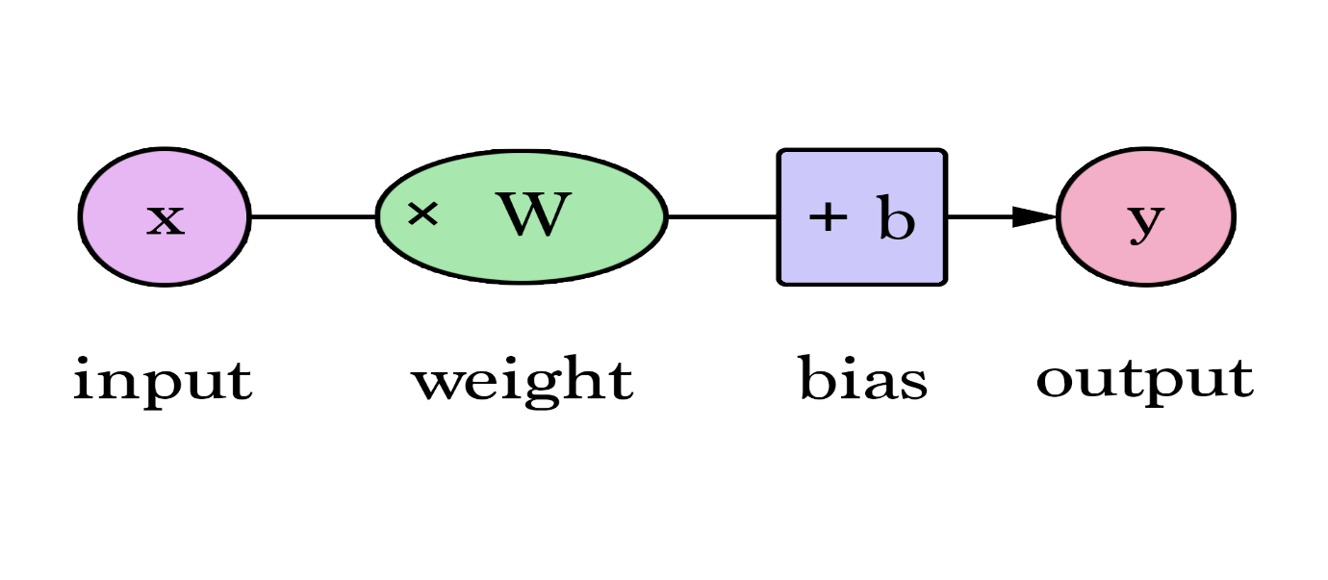

How does Weight work?
It is helpful to imagine a theoretical neural network to understand how weights work. Within a neural network there's an input layer, that takes the input signals and passes them to the next layer.
Next, the neural network contains a series of hidden layers which apply transformations to the input data. It is within the nodes of the hidden layers that the weights are applied. For example, a single node may take the input data and multiply it by an assigned weight value, then add a bias before passing the data to the next layer. The final layer of the neural network is also known as the output layer. The output layer often tunes the inputs from the hidden layers to produces the desired numbers in a specified range.

Weight vs. Bias
Weights and bias are both learnable parameters inside the network. A teachable neural network will randomize both the weight and bias values before learning initially begins. As training continues, both parameters are adjusted toward the desired values and the correct output. The two parameters differ in the extent of their influence upon the input data. Simply, bias represents how far off the predictions are from their intended value. Biases make up the difference between the function's output and its intended output. A low bias suggest that the network is making more assumptions about the form of the output, whereas a high bias value makes less assumptions about the form of the output. Weights, on the other hand, can be thought of as the strength of the connection. Weight affects the amount of influence a change in the input will have upon the output. A low weight value will have no change on the input, and alternatively a larger weight value will more significantly change the output.

Weights control the signal (or the strength of the connection) between two neurons. In other words, a weight decides how much influence the input will have on the output. Biases, which are constant, are an additional input into the next layer that will always have the value of 1. Bias can be positive or negative, increasing or decreasing a neuron's output.
In the context of neural networks and deep learning, weights and biases are fundamental components that play a crucial role in the functioning and training of neurons.

### Neuron in a Neural Network:
A neuron in a neural network is a mathematical function that takes multiple inputs, applies weights to these inputs, sums them up, adds a bias, and then applies an activation function to produce an output. This output is then passed on to the next layer of neurons in the network.
### Weights:
Weights are the parameters that the neural network learns during the training process. Each input to a neuron is associated with a weight. The weight represents the strength of the connection between the input and the neuron. A higher weight means the input has more influence on the neuron's output, and a lower weight means less influence.
Mathematically, for a neuron \(i\) in a layer, the weighted sum of inputs (\(z_i\)) is calculated as follows:
\[z_i = \sum_{j=1}^{n} (x_j \times w_{ij})\]
where:
- \(x_j\) is the \(j\)-th input to the neuron,
- \(w_{ij}\) is the weight associated with the connection between the \(j\)-th input and the \(i\)-th neuron,
- \(n\) is the total number of inputs.
During training, these weights are adjusted using optimization algorithms (e.g., gradient descent) to minimize a defined loss function, effectively tuning the network to make accurate predictions.
### Bias:
The bias is an additional parameter associated with each neuron. It allows the activation function to shift left or right, providing the model with more flexibility. The bias helps the neuron to activate even when the weighted sum of inputs is zero.
Mathematically, the total input to neuron \(i\) (\(a_i\)) is calculated by adding the bias (\(b_i\)) to the weighted sum (\(z_i\)):
\[a_i = z_i + b_i\]
In summary, weights determine the strength of connections between neurons and are adjusted during training to optimize performance. The bias helps in adjusting the activation function and provides the neuron with the ability to activate even for small input values. Together, weights and biases enable the neural network to learn and generalize from input data to produce meaningful output predictions.
The activation function calculates a weighted total and then adds bias to it to decide whether a neuron should be activated or not. The Activation Function’s goal is to introduce non-linearity into a neuron’s output.
A Neural Network without an activation function is basically a linear regression model in Deep Learning, since these functions perform non-linear computations on the input of a Neural Network, enabling it to learn and do more complex tasks.
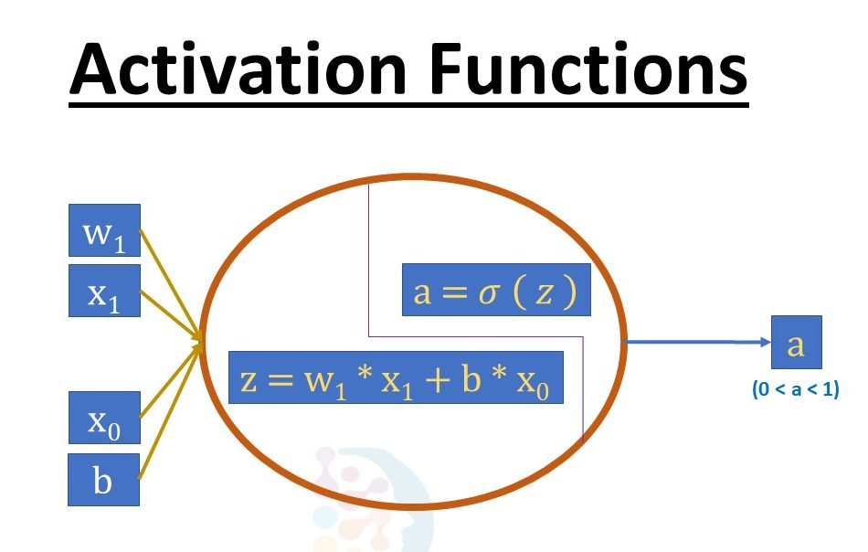thought of as analogous to the role of a
Without an activation function, a Neural Network is just a linear regression model. The activation function transforms the input in a non-linear way, allowing it to learn and as well as accomplish more complex tasks.

Activation Functions
An activation function in a neural network defines how the weighted sum of the input is transformed into an output from a node or nodes in a layer of the network.
Sometimes the activation function is called a “transfer function.” If the output range of the activation function is limited, then it may be called a “squashing function.” Many activation functions are nonlinear and may be referred to as the “nonlinearity” in the layer or the network design.
The choice of activation function has a large impact on the capability and performance of the neural network, and different activation functions may be used in different parts of the model.
Technically, the activation function is used within or after the internal processing of each node in the network, although networks are designed to use the same activation function for all nodes in a layer.
A network may have three types of layers: input layers that take raw input from the domain, hidden layers that take input from another layer and pass output to another layer, and output layers that make a prediction.
All hidden layers typically use the same activation function. The output layer will typically use a different activation function from the hidden layers and is dependent upon the type of prediction required by the model.
Activation functions are also typically differentiable, meaning the first-order derivative can be calculated for a given input value. This is required given that neural networks are typically trained using the backpropagation of error algorithm that requires the derivative of prediction error in order to update the weights of the model.
Gradient Descent Algorithm iteratively calculates the next point using gradient at the current position, scales it (by a learning rate) and subtracts obtained value from the current position (makes a step). It subtracts the value because we want to minimise the function (to maximise it would be adding).
Backpropagation, short for "backward propagation of errors," is an algorithm for supervised learning of artificial neural networks using gradient descent. Given an artificial neural network and an error function, the method calculates the gradient of the error function with respect to the neural network's weights.
There are many different types of activation functions used in neural networks, although perhaps only a small number of functions used in practice for hidden and output layers.

Activation for Hidden Layers
A hidden layer in a neural network is a layer that receives input from another layer (such as another hidden layer or an input layer) and provides output to another layer (such as another hidden layer or an output layer).
A hidden layer does not directly contact input data or produce outputs for a model, at least in general.
A neural network may have zero or more hidden layers.
Typically, a differentiable nonlinear activation function is used in the hidden layers of a neural network. This allows the model to learn more complex functions than a network trained using a linear activation function.
In order to get access to a much richer hypothesis space that would benefit from deep representations, you need a non-linearity, or activation function.
There are perhaps three activation functions you may want to consider for use in hidden layers; they are:
- Rectified Linear Activation (ReLU)
- Logistic (Sigmoid)
- Hyperbolic Tangent (Tanh)
This is not an exhaustive list of activation functions used for hidden layers, but they are the most commonly used.

ReLU Hidden Layer Activation Function
The rectified linear activation function, or ReLU activation function, is perhaps the most common function used for hidden layers.

It is common because it is both simple to implement and effective at overcoming the limitations of other previously popular activation functions, such as Sigmoid and Tanh. Specifically, it is less susceptible to vanishing gradients that prevent deep models from being trained, although it can suffer from other problems like saturated or “dead” units.
The ReLU function is calculated as follows:
- max(0.0, x)
This means that if the input value (x) is negative, then a value 0.0 is returned, otherwise, the value is returned.
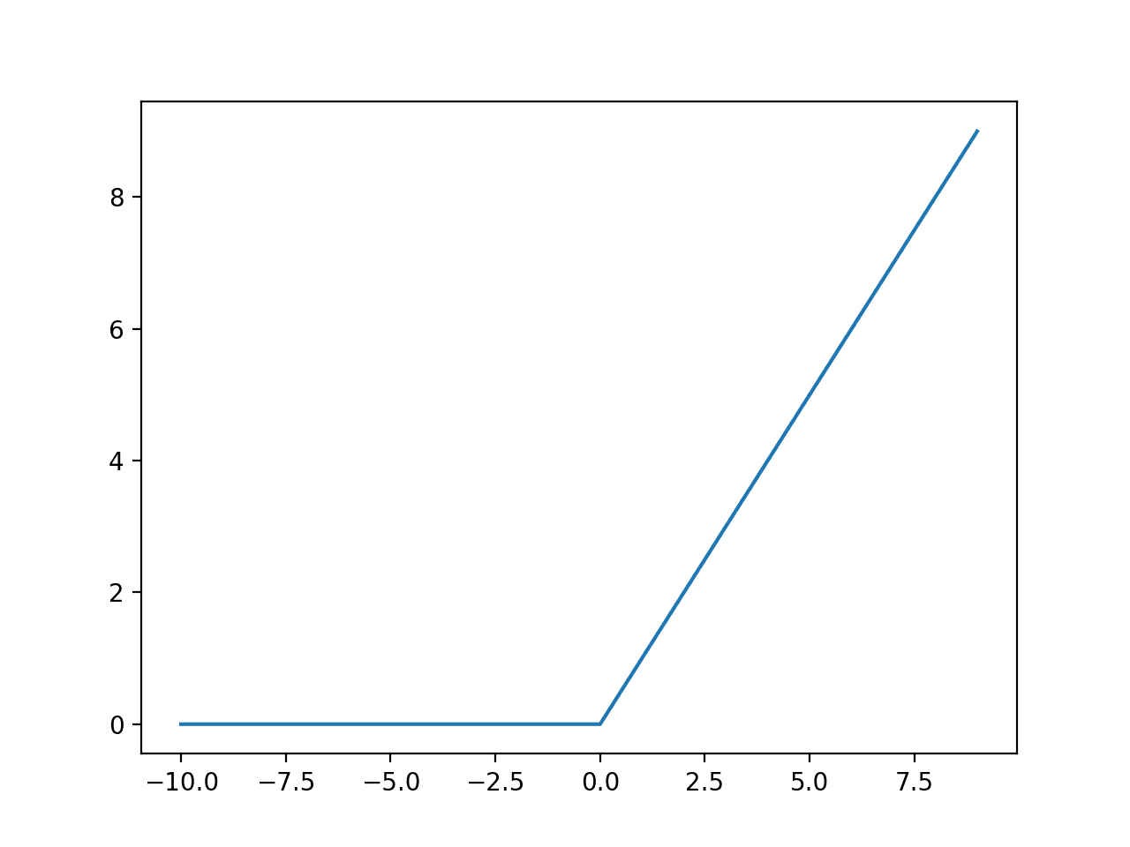
When using the ReLU function for hidden layers, it is a good practice to use a “He Normal” or “He Uniform” weight initialization and scale input data to the range 0-1 (normalize) prior to training.

Sigmoid Hidden Layer Activation Function
The sigmoid activation function is also called the logistic function.
It is the same function used in the logistic regression classification algorithm.
The function takes any real value as input and outputs values in the range 0 to 1. The larger the input (more positive), the closer the output value will be to 1.0, whereas the smaller the input (more negative), the closer the output will be to 0.0.
The sigmoid activation function is calculated as follows:
- 1.0 / (1.0 + e^-x)
Where e is a mathematical constant, which is the base of the natural logarithm.
We can see the familiar S-shape of the sigmoid activation function.
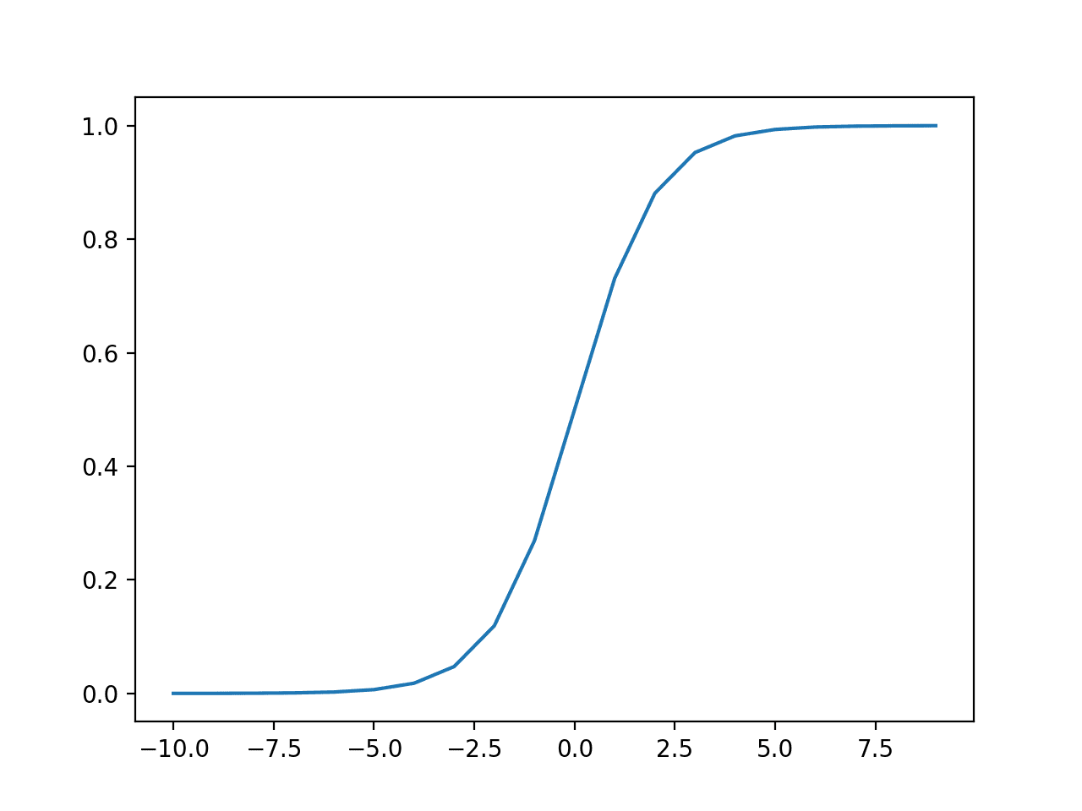
Plot of Inputs vs. Outputs for the Sigmoid Activation Function.
When using the Sigmoid function for hidden layers, it is a good practice to use a “Xavier Normal” or “Xavier Uniform” weight initialization (also referred to Glorot initialization, named for Xavier Glorot) and scale input data to the range 0-1 (e.g. the range of the activation function) prior to training.

Tanh Hidden Layer Activation Function
The hyperbolic tangent activation function is also referred to simply as the Tanh (also “tanh” and “TanH“) function.
It is very similar to the sigmoid activation function and even has the same S-shape.
The function takes any real value as input and outputs values in the range -1 to 1. The larger the input (more positive), the closer the output value will be to 1.0, whereas the smaller the input (more negative), the closer the output will be to -1.0.
The Tanh activation function is calculated as follows:
- (e^x – e^-x) / (e^x + e^-x)
Where e is a mathematical constant that is the base of the natural logarithm.
We can see the familiar S-shape of the Tanh activation function.
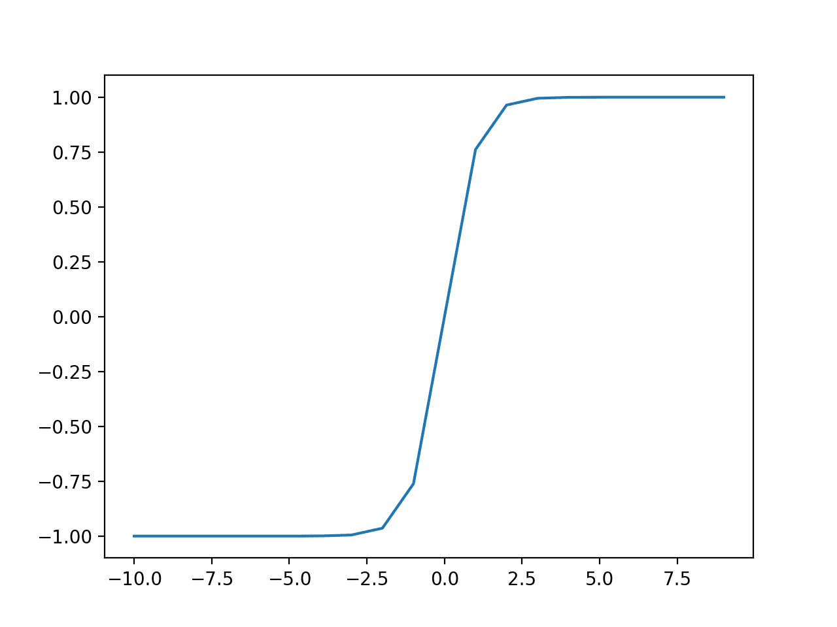
Plot of Inputs vs. Outputs for the Tanh Activation Function.
When using the TanH function for hidden layers, it is a good practice to use a “Xavier Normal” or “Xavier Uniform” weight initialization (also referred to Glorot initialization, named for Xavier Glorot) and scale input data to the range -1 to 1 (e.g. the range of the activation function) prior to training.

How to Choose a Hidden Layer Activation Function
A neural network will almost always have the same activation function in all hidden layers.
It is most unusual to vary the activation function through a network model.
Traditionally, the sigmoid activation function was the default activation function in the 1990s. Perhaps through the mid to late 1990s to 2010s, the Tanh function was the default activation function for hidden layers.
Both the sigmoid and Tanh functions can make the model more susceptible to problems during training, via the so-called vanishing gradients problem.
The activation function used in hidden layers is typically chosen based on the type of neural network architecture.
Modern neural network models with common architectures, such as MLP and CNN, will make use of the ReLU activation function, or extensions.
Recurrent networks still commonly use Tanh or sigmoid activation functions, or even both. For example, the LSTM commonly uses the Sigmoid activation for recurrent connections and the Tanh activation for output.
- Multilayer Perceptron (MLP): ReLU activation function.
- Convolutional Neural Network (CNN): ReLU activation function.
- Recurrent Neural Network: Tanh and/or Sigmoid activation function.

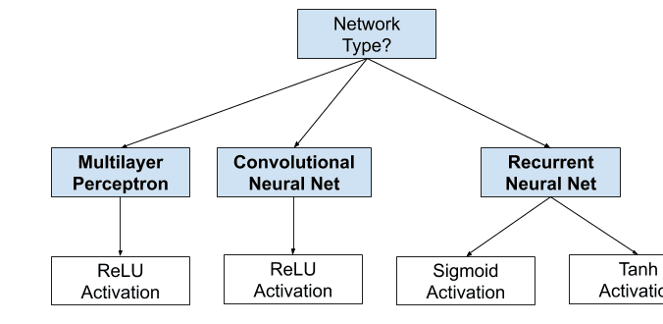
How to Choose a Hidden Layer Activation Function

Activation for Output Layers
The output layer is the layer in a neural network model that directly outputs a prediction.
All feed-forward neural network models have an output layer.
Feed forward neural networks are artificial neural networks in which nodes do not form loops. This type of neural network is also known as a multi-layer neural network as all information is only passed forward. During data flow, input nodes receive data, which travel through hidden layers, and exit output nodes.
There are perhaps three activation functions you may want to consider for use in the output layer; they are:
- Linear
- Logistic (Sigmoid)
- Softmax
This is not an exhaustive list of activation functions used for output layers, but they are the most commonly used.

Linear Output Activation Function
The linear activation function is also called “identity” (multiplied by 1.0) or “no activation.”
This is because the linear activation function does not change the weighted sum of the input in any way and instead returns the value directly.

Sigmoid Output Activation Function
The sigmoid of logistic activation function was described above.

Softmax Output Activation Function

Max(2,3) = 3

A = [2,3]

A[0] = 2

A[1] = 3

Argmax(2,3) = 0 , 1
The softmax function outputs a vector of values that sum to 1.0 that can be interpreted as probabilities of class membership.
It is related to the argmax function that outputs a 0 for all options and 1 for the chosen option. Softmax is a “softer” version of argmax that allows a probability-like output of a winner-take-all function.
As such, the input to the function is a vector of real values and the output is a vector of the same length with values that sum to 1.0 like probabilities.
The softmax function is calculated as follows:
- e^x / sum(e^x)
Where x is a vector of outputs and e is a mathematical constant that is the base of the natural logarithm.
Target labels used to train a model with the softmax activation function in the output layer will be vectors with 1 for the target class and 0 for all other classes.

How to Choose an Output Activation Function
You must choose the activation function for your output layer based on the type of prediction problem that you are solving.
Specifically, the type of variable that is being predicted.
For example, you may divide prediction problems into two main groups, predicting a categorical variable (classification) and predicting a numerical variable (regression).
If your problem is a regression problem, you should use a linear activation function.
- Regression: One node, linear activation.
If your problem is a classification problem, then there are three main types of classification problems and each may use a different activation function.
Predicting a probability is not a regression problem; it is classification. In all cases of classification, your model will predict the probability of class membership (e.g. probability that an example belongs to each class) that you can convert to a crisp class label by rounding (for sigmoid) or argmax (for softmax).
If there are two mutually exclusive classes (binary classification), then your output layer will have one node and a sigmoid activation function should be used. If there are more than two mutually exclusive classes (multiclass classification), then your output layer will have one node per class and a softmax activation should be used. If there are two or more mutually inclusive classes (multilabel classification), then your output layer will have one node for each class and a sigmoid activation function is used.
- Binary Classification: One node, sigmoid activation.
- Multiclass Classification: One node per class, softmax activation.
- Multilabel Classification: One node per class, sigmoid activation.
The figure below summarizes how to choose an activation function for the output layer of your neural network model.

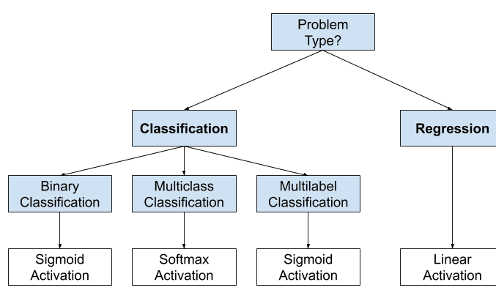

Biological Neurons
Typical biological neurons are individual cells, each composed of the main body of the cell along with many tendrils that extend from that body. The body, or soma, houses the machinery for maintaining basic cell functions and energy processing (e.g., the DNA-containing nucleus, and organelles for building proteins and processing sugar and oxygen). There are two types of tendrils: dendrites, which receive information from other neurons and bring it to the cell body, and axons, which send information from the cell body to other neurons.
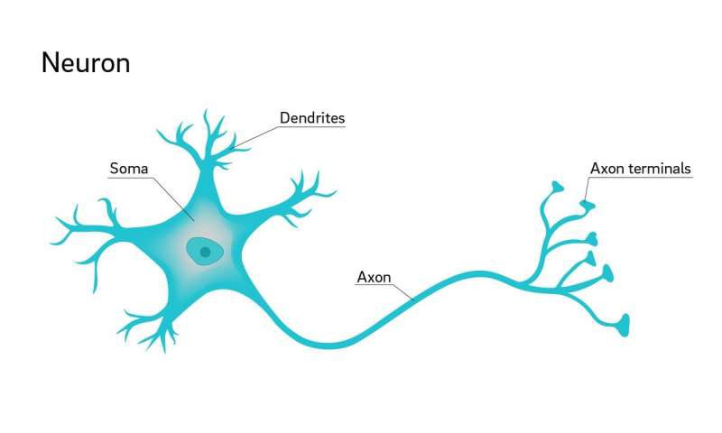
Information transmission from a transmitting neuron to a receiving neuron is roughly composed of three stages. First, the transmitting neuron generates a spatially- and temporally-confined electrical burst, or spike, that travels along the neuron’s axon (and axonal branches) from the cell body to the terminal ends of the axon. An axon terminal of the transmitting neuron is “connected” to a dendrite of a receiving neuron by a synapse. The spike causes the transmitting neuron’s synapse to release chemicals, or neurotransmitters, that travel the short distance between the two neurons via diffusion.
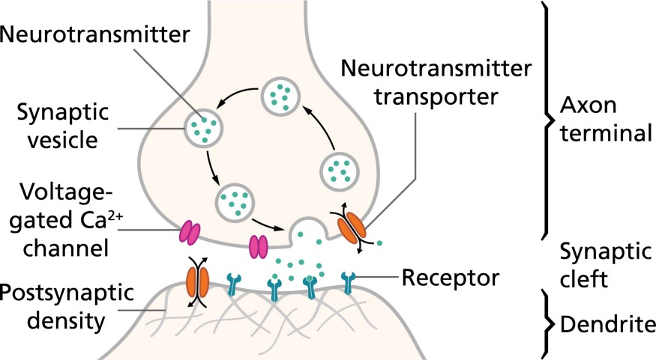
Specialized receptors on the receiving neuron recognize (bind with) specific neurotransmitters, and initiate a number of cellular events (most of which are ignored in this post) when neurotransmitter molecules bind to the receptors. One of those events is the opening of cellular channels which initiate another electrical wave, this time propagating through the receiving neuron’s dendrite toward its cell body (this may be in the form of a spike, but typically the wave is more spatially diffuse than spike-based transmission along axons — think of water being pushed through a pipe).
Thus, information from one neuron can be transmitted to another. When a neuron receives multiple excitatory spikes from multiple transmitting neurons, that electrical energy is accumulated at the neuron’s cell body, and if enough energy is accumulated in a short period of time, the neuron will generate outgoing spikes of its own, and relay them to other neurons.
There are three remaining aspects to discuss in order to understand the Modeling that takes us from biological neurons to deep learning neurons.
- Rate-coding
- Synaptic strength
- Excitatory and inhibitory transmission

Rate-coding
A neuron that receives only a small number of excitatory spikes will produce and send few spikes of its own, if any. If that same neuron receives many excitatory spikes it will (typically) send many spikes of its own. Although spikes in biological neurons have a distinctly temporal characteristic, the temporal resolution is “blurred” in deep learning neurons. For a given unit of time, the spiking activity of the deep learning neuron is represented as a number of spikes (an integer) or more typically, an average spiking rate (a floating-point number).
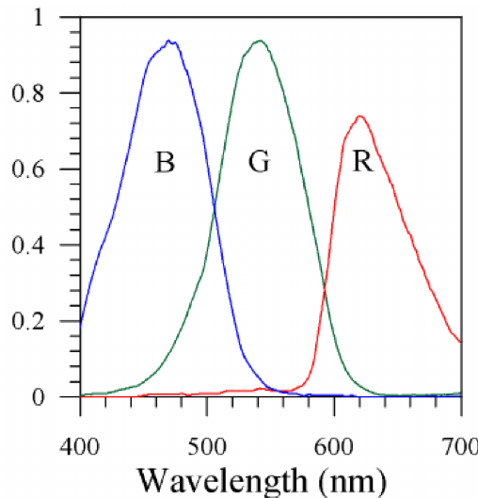
In this contrived example, three neurons in the visual system receive indirect input from one of three groups of color-sensitive cones cells in the eye. Each neuron is therefore maximally responsive to a particular wavelength of light, and spiking activity is reported as the average spike rate (normalized to [0,1]). Thus, the input wavelength is “encoded” by the collective spike rates of the three neurons.
Note, however, that in biological neurons, information is encoded in the relative timing of spikes in individual or multiple neurons, not just in the individual neuron spiking rates. Thus, this type of information coding and transmission is absent in deep learning neurons. The impact of this will be discussed further below.

Synaptic strength
Not all spikes are equal. When a propagating spike reaches an axonal terminal, the amount of electrical energy that ultimately arises in the dendrite of the receiving neuron depends on the strength of the intervening synapse. This strength is reflective of a number of underlying physiological factors including the amount of neurotransmitter available for release in the transmitting neuron and the number of neurotransmitter receptors on the receiving neuron.
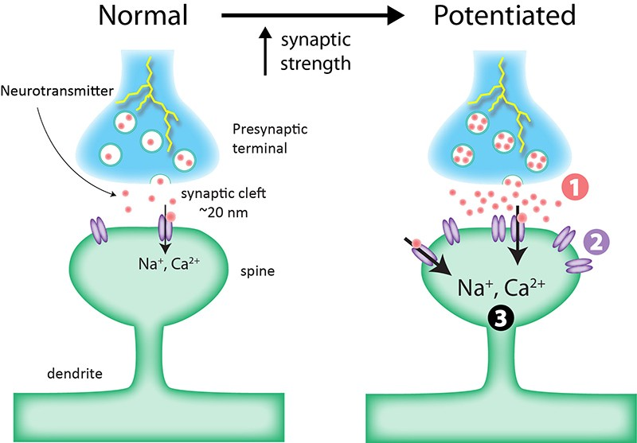
Regardless, in deep learning neurons, synaptic strength is represented by a single floating-point number, and is more commonly referred to as the weight of the synapse.

Excitatory and inhibitory neurotransmitters
Up until now, we have only considered excitatory neurotransmission. In that case, spikes received from a transmitting neuron increase the likelihood that a receiving neuron will also spike. This is due to the particular properties of the activated receptors on the receiving neuron. Although an oversimplification, one can group neurotransmitters and their receptors into an excitatory class and an inhibitory class. When an inhibitory neurotransmitter binds to a inhibitory receptor, the electrical energy at the dendrite in the receiving neuron is reduced rather than increased. In general, neurons have receptors for both excitatory and inhibitory neurotransmitters, but can release (transmit) only one class or the other. In the mammalian cortex, there are many more excitatory neurons (which release the neurotransmitter glutamate with each spike) than inhibitory neurons (which release the neurotransmitter GABA with each spike). Nonetheless, these inhibitory neurons are important for increasing information selectivity in receiving neurons, gating neurons off and thus contributing to information routing, and preventing epileptic activity (chaotic firing of many neurons in the network).
In deep learning networks, no distinction is made between excitatory and inhibitory neurons (those having only an excitatory or inhibitory neurotransmitter, respectively). All neurons have output activity that is greater than zero, and it is the synapses that model inhibition. The weights of the synapses are allowed to be negative, in which case inputs from transmitting neurons cause the output of the receiving neuron to be reduced.

Differences between ANN and BNN:
S.No. | ANN | BNN
1. | It is short for Artificial Neural Network. | It is short for Biological Neural Network.
2. | Processing speed is fast as compared to Biological Neural Network. | They are slow in processing information.
3. | Allocation for Storage to a new process is strictly irreplaceable as the old location is saved for the previous process. | Allocation for storage to a new process is easy as it is added just by adjusting the interconnection strengths.
4. | Processes operate in sequential mode. | The process can operate in massive parallel operations.
5. | If any information gets corrupted in the memory it cannot be retrieved. | Information is distributed into the network throughout into sub-nodes, even if it gets corrupted it can be retrieved.
6. | The activities are continuously monitored by a control unit. | There is no control unit to monitor the information being processed into the network.

